**FULL ADDER**

**EXP.NO: 29**

**AIM:**

To design and implement the full adder using Logisim simulator.

**PROCEDURE:**

1. Pick and place the necessary gates.
2. Insert 3 inputs into the canvas.
3. Connect the inputs to the XOR gate, AND gate and OR gate.
4. Insert 2 outputs into the canvas.
5. Make the connections using the connecting wires.
6. Verify the truth table.

**TRUTH TABLE:**

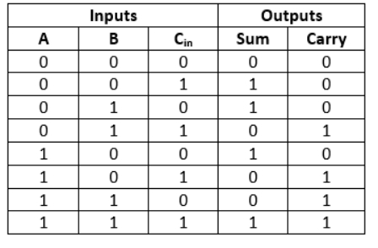

Sum=(A ⊕ B) ⊕ Cin

Carry=A.B + (A ⊕ B)

**OUTPUT**

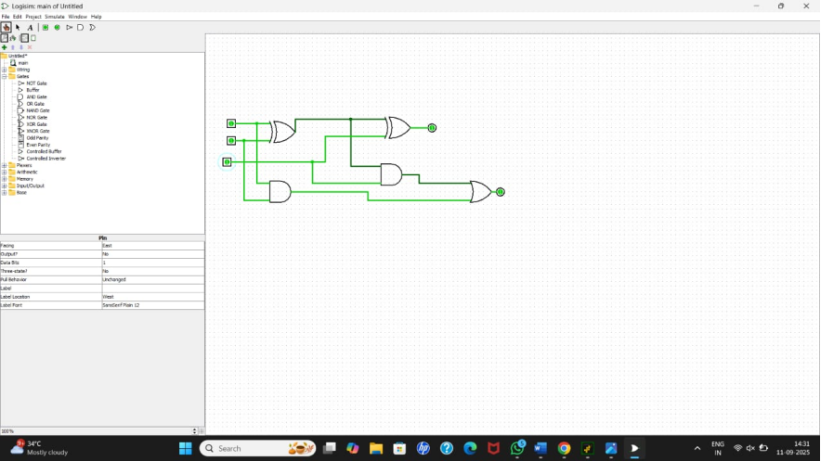

**RESULT:** Thus full adder has been designed and implemented successfully using logisim simulator.